| **Name** | **ID** |
| --- | --- |
|  |  |

**Imagine you have a file structure system where each file can point to 2 other folder[you can consider as left and right path]. Now keep in mind that each folder can either contain a terminal point (lets say a .txt file) or it can contain the path to another folder or it can be empty/None. In this task you are assignment to make a code which will traverse the whole file system to return how many txt files there are?**

**For example 2 file system and their corresponding result is given here:**

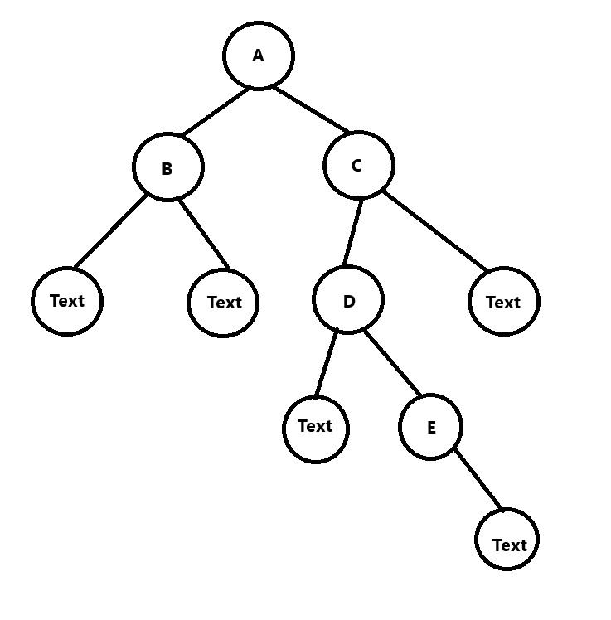

1. **You have to make this tree using either manually connecting all the nodes or using an array representation and build the tree recursively however you like. [Complete the tree_maker()]. Keep in mind the element of the nodes are either alphabet A,B,C etc or for the text file the element is “.txt”.**
2. **Complete the inorder() which will help you traverse the tree in an in-order sequence.** 
   1. **Output : .txt B .txt A .txt D E .txt C .txt**
3. **Complete the findText() which will return the count of the “.txt” files in this file system.**
   1. **Output: 5**